Kinematics Review Quiz Multiple Choice Questions

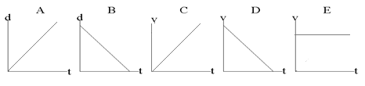
1. Which of the following graph(s) represent(s) uniform motion?

a. | A and B only | d. | C and D only
b. | A and E only | e. | C, D and E only
c. | A, B and E only

2. Two hikers set out from the same spot and arrive at the same destination but they take different routes.
Which of the following quantities must be the same for both hikers?
a. | displacement | d. | average speed
b. | distance | e. | acceleration
c. | average velocity

3. The graph below shows a position-time graph
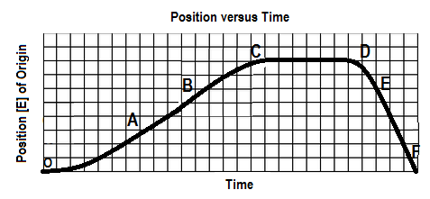

Over which interval is the object moving west and speeding up?
a. OA b. BC c.CD d. DE e.EF

4. The area under a velocity-time graph represents
a. | displacement | d. | instantaneous velocity
b. | acceleration | e. | average velocity
c. | change in velocity

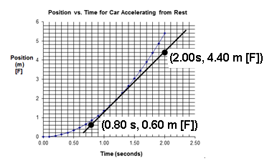
5. A position-time graph for a car accelerating uniformly from rest is shown below. A tangent has been drawn to the curve at time 1.20 seconds and two points on the tangent line are shown. From this information we can determine that:

a. The instantaneous acceleration is 0.32 m/s² [F].
b. The instantaneous velocity is 0.32 m/s [F].
c. The instantaneous acceleration is 3.2 m/s² [F].
d. The instantaneous velocity is 3.2 m/s [F].

